[[](https://www.facebook.com/photo.php?fbid=298069623681030&set=pcb.298069667014359&type=1)](https://www.facebook.com/photo.php?fbid=298069623681030&set=pcb.298069667014359&type=1)

[[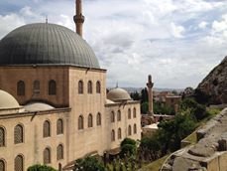](https://www.facebook.com/photo.php?fbid=298069653681027&set=pcb.298069667014359&type=1)](https://www.facebook.com/photo.php?fbid=298069653681027&set=pcb.298069667014359&type=1)

[[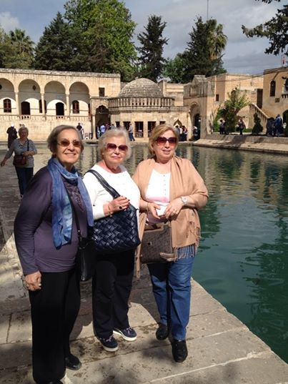](https://www.facebook.com/photo.php?fbid=298067223681270&set=pcb.298067260347933&type=1)](https://www.facebook.com/photo.php?fbid=298067223681270&set=pcb.298067260347933&type=1)

[[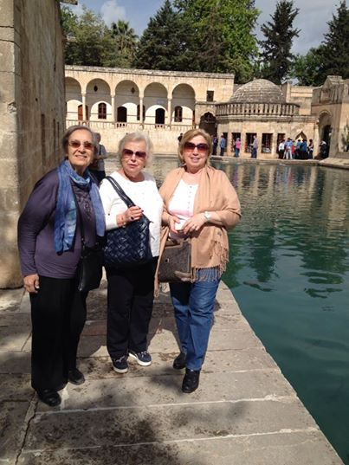](https://www.facebook.com/photo.php?fbid=298067250347934&set=pcb.298067260347933&type=1)](https://www.facebook.com/photo.php?fbid=298067250347934&set=pcb.298067260347933&type=1)

Formun Üstü

[[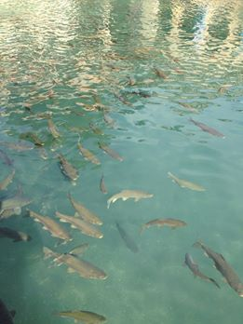](https://www.facebook.com/photo.php?fbid=298067083681284&set=pcb.298067173681275&type=1)](https://www.facebook.com/photo.php?fbid=298067083681284&set=pcb.298067173681275&type=1)

[[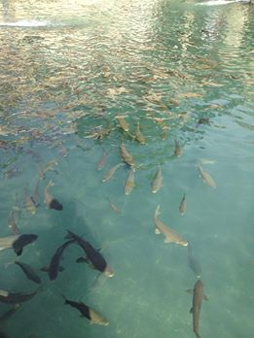](https://www.facebook.com/photo.php?fbid=298067097014616&set=pcb.298067173681275&type=1)](https://www.facebook.com/photo.php?fbid=298067097014616&set=pcb.298067173681275&type=1)

[[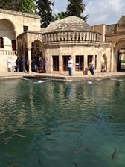](https://www.facebook.com/photo.php?fbid=298067120347947&set=pcb.298067173681275&type=1)](https://www.facebook.com/photo.php?fbid=298067120347947&set=pcb.298067173681275&type=1)

[[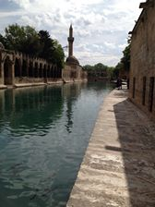](https://www.facebook.com/photo.php?fbid=298067140347945&set=pcb.298067173681275&type=1)](https://www.facebook.com/photo.php?fbid=298067140347945&set=pcb.298067173681275&type=1)

[[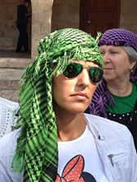](https://www.facebook.com/photo.php?fbid=298067163681276&set=pcb.298067173681275&type=1)](https://www.facebook.com/photo.php?fbid=298067163681276&set=pcb.298067173681275&type=1)

Formun Üstü

[[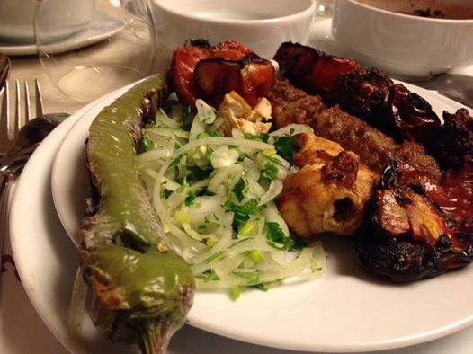](https://www.facebook.com/photo.php?fbid=297887303699262&set=pcb.297887353699257&type=1)](https://www.facebook.com/photo.php?fbid=297887303699262&set=pcb.297887353699257&type=1)

[[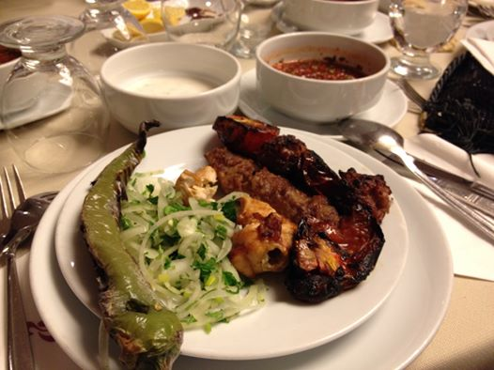](https://www.facebook.com/photo.php?fbid=297887327032593&set=pcb.297887353699257&type=1)](https://www.facebook.com/photo.php?fbid=297887327032593&set=pcb.297887353699257&type=1)

Formun Üstü

[[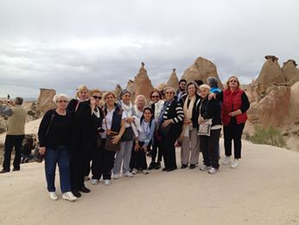](https://www.facebook.com/photo.php?fbid=297537913734201&set=pcb.297538193734173&type=1)](https://www.facebook.com/photo.php?fbid=297537913734201&set=pcb.297538193734173&type=1)

[[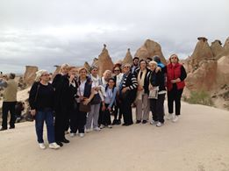](https://www.facebook.com/photo.php?fbid=297537977067528&set=pcb.297538193734173&type=1)](https://www.facebook.com/photo.php?fbid=297537977067528&set=pcb.297538193734173&type=1)

[[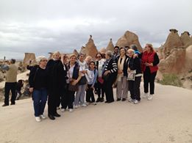](https://www.facebook.com/photo.php?fbid=297538043734188&set=pcb.297538193734173&type=1)](https://www.facebook.com/photo.php?fbid=297538043734188&set=pcb.297538193734173&type=1)

[[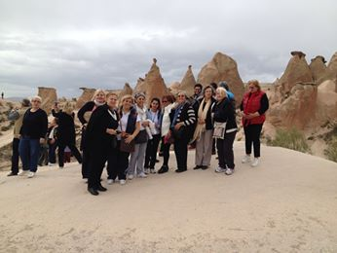](https://www.facebook.com/photo.php?fbid=297538097067516&set=pcb.297538193734173&type=1)](https://www.facebook.com/photo.php?fbid=297538097067516&set=pcb.297538193734173&type=1)

[[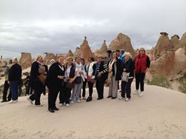](https://www.facebook.com/photo.php?fbid=297538150400844&set=pcb.297538193734173&type=1)](https://www.facebook.com/photo.php?fbid=297538150400844&set=pcb.297538193734173&type=1)

Formun Üstü

[[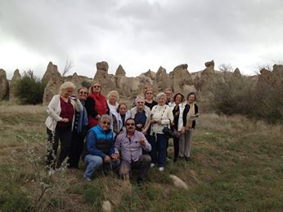](https://www.facebook.com/photo.php?fbid=297428633745129&set=pcb.297428877078438&type=1)](https://www.facebook.com/photo.php?fbid=297428633745129&set=pcb.297428877078438&type=1)

[[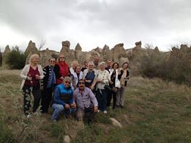](https://www.facebook.com/photo.php?fbid=297428677078458&set=pcb.297428877078438&type=1)](https://www.facebook.com/photo.php?fbid=297428677078458&set=pcb.297428877078438&type=1)

[[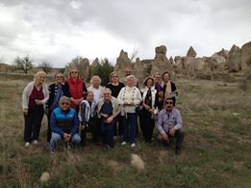](https://www.facebook.com/photo.php?fbid=297428707078455&set=pcb.297428877078438&type=1)](https://www.facebook.com/photo.php?fbid=297428707078455&set=pcb.297428877078438&type=1)

[[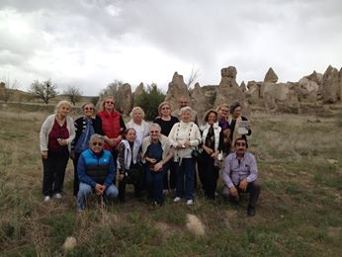](https://www.facebook.com/photo.php?fbid=297428743745118&set=pcb.297428877078438&type=1)](https://www.facebook.com/photo.php?fbid=297428743745118&set=pcb.297428877078438&type=1)

[[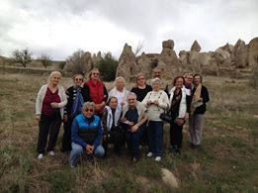](https://www.facebook.com/photo.php?fbid=297428807078445&set=pcb.297428877078438&type=1)](https://www.facebook.com/photo.php?fbid=297428807078445&set=pcb.297428877078438&type=1)

Formun Üstü

[[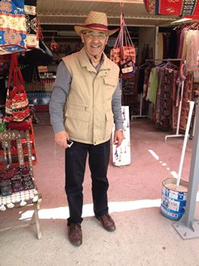](https://www.facebook.com/photo.php?fbid=297416150413044&set=pcb.297416400413019&type=1)](https://www.facebook.com/photo.php?fbid=297416150413044&set=pcb.297416400413019&type=1)

[[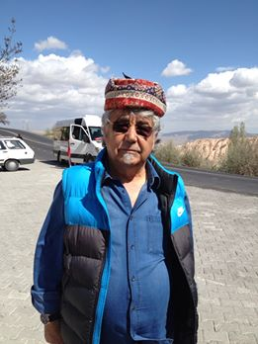](https://www.facebook.com/photo.php?fbid=297416167079709&set=pcb.297416400413019&type=1)](https://www.facebook.com/photo.php?fbid=297416167079709&set=pcb.297416400413019&type=1)

[[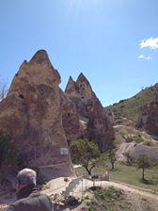](https://www.facebook.com/photo.php?fbid=297416183746374&set=pcb.297416400413019&type=1)](https://www.facebook.com/photo.php?fbid=297416183746374&set=pcb.297416400413019&type=1)

[[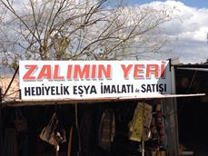](https://www.facebook.com/photo.php?fbid=297416200413039&set=pcb.297416400413019&type=1)](https://www.facebook.com/photo.php?fbid=297416200413039&set=pcb.297416400413019&type=1)

[[](https://www.facebook.com/photo.php?fbid=297416220413037&set=pcb.297416400413019&type=1)](https://www.facebook.com/photo.php?fbid=297416220413037&set=pcb.297416400413019&type=1)

Formun Altı

[[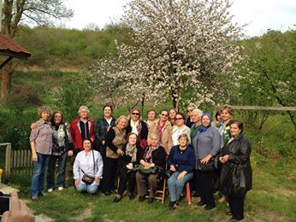](https://www.facebook.com/photo.php?fbid=296420307179295&set=pcb.296420660512593&type=1)](https://www.facebook.com/photo.php?fbid=296420307179295&set=pcb.296420660512593&type=1)

[[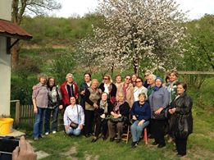](https://www.facebook.com/photo.php?fbid=296420417179284&set=pcb.296420660512593&type=1)](https://www.facebook.com/photo.php?fbid=296420417179284&set=pcb.296420660512593&type=1)

[[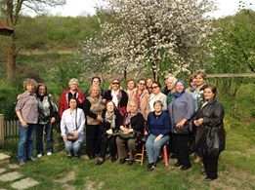](https://www.facebook.com/photo.php?fbid=296420500512609&set=pcb.296420660512593&type=1)](https://www.facebook.com/photo.php?fbid=296420500512609&set=pcb.296420660512593&type=1)

[[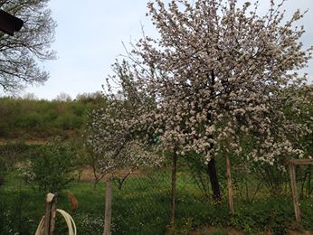](https://www.facebook.com/photo.php?fbid=296420603845932&set=pcb.296420660512593&type=1)](https://www.facebook.com/photo.php?fbid=296420603845932&set=pcb.296420660512593&type=1)

[[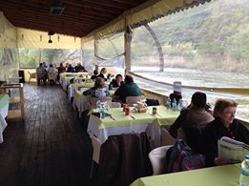](https://www.facebook.com/photo.php?fbid=296420650512594&set=pcb.296420660512593&type=1)](https://www.facebook.com/photo.php?fbid=296420650512594&set=pcb.296420660512593&type=1)

Formun Üstü

[[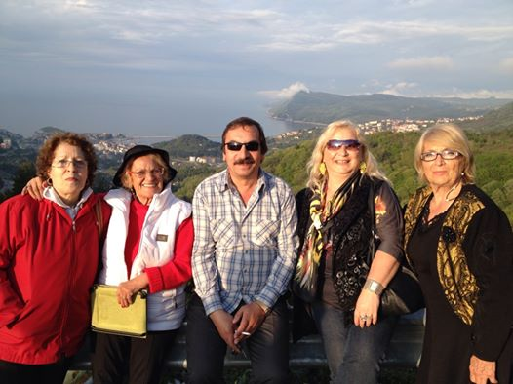](https://www.facebook.com/photo.php?fbid=294955220659137&set=pcb.294955573992435&type=1)](https://www.facebook.com/photo.php?fbid=294955220659137&set=pcb.294955573992435&type=1)

[[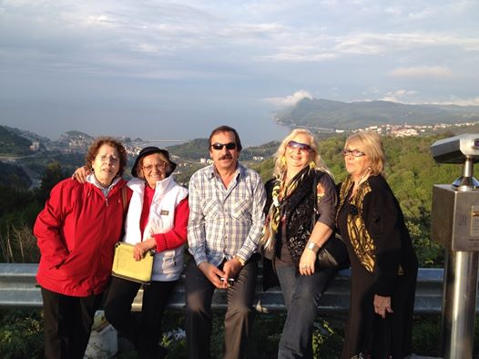](https://www.facebook.com/photo.php?fbid=294955560659103&set=pcb.294955573992435&type=1)](https://www.facebook.com/photo.php?fbid=294955560659103&set=pcb.294955573992435&type=1)

-

[[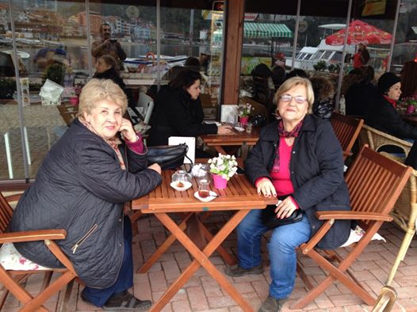](https://www.facebook.com/photo.php?fbid=294911557330170&set=a.107555026065825.13664.100004339841178&type=1&relevant_count=1)](https://www.facebook.com/photo.php?fbid=294911557330170&set=a.107555026065825.13664.100004339841178&type=1&relevant_count=1)

[[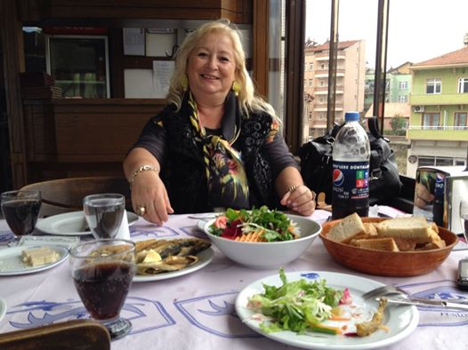](https://www.facebook.com/photo.php?fbid=294888797332446&set=pcb.294888837332442&type=1)](https://www.facebook.com/photo.php?fbid=294888797332446&set=pcb.294888837332442&type=1)

[[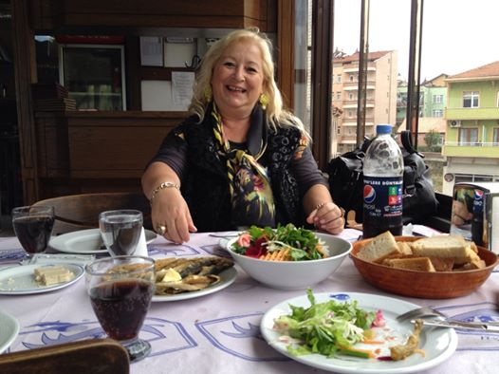](https://www.facebook.com/photo.php?fbid=294888827332443&set=pcb.294888837332442&type=1)](https://www.facebook.com/photo.php?fbid=294888827332443&set=pcb.294888837332442&type=1)

Formun Üstü

[[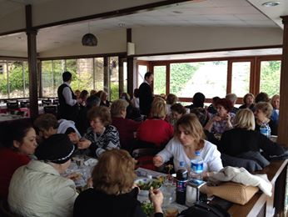](https://www.facebook.com/photo.php?fbid=294887090665950&set=pcb.294887313999261&type=1)](https://www.facebook.com/photo.php?fbid=294887090665950&set=pcb.294887313999261&type=1)

[[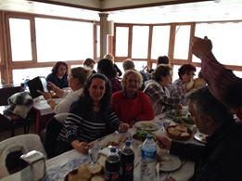](https://www.facebook.com/photo.php?fbid=294887107332615&set=pcb.294887313999261&type=1)](https://www.facebook.com/photo.php?fbid=294887107332615&set=pcb.294887313999261&type=1)

[[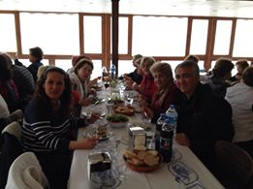](https://www.facebook.com/photo.php?fbid=294887133999279&set=pcb.294887313999261&type=1)](https://www.facebook.com/photo.php?fbid=294887133999279&set=pcb.294887313999261&type=1)

[[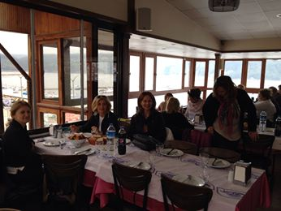](https://www.facebook.com/photo.php?fbid=294887167332609&set=pcb.294887313999261&type=1)](https://www.facebook.com/photo.php?fbid=294887167332609&set=pcb.294887313999261&type=1)

[[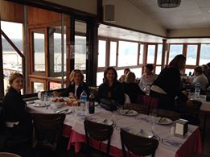](https://www.facebook.com/photo.php?fbid=294887197332606&set=pcb.294887313999261&type=1)](https://www.facebook.com/photo.php?fbid=294887197332606&set=pcb.294887313999261&type=1)

Formun Üstü

[[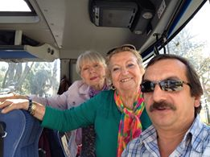](https://www.facebook.com/photo.php?fbid=291941770960482&set=pcb.291941814293811&type=1)](https://www.facebook.com/photo.php?fbid=291941770960482&set=pcb.291941814293811&type=1)

[[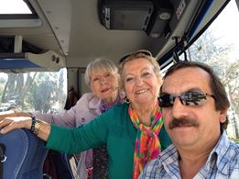](https://www.facebook.com/photo.php?fbid=291941804293812&set=pcb.291941814293811&type=1)](https://www.facebook.com/photo.php?fbid=291941804293812&set=pcb.291941814293811&type=1)

Formun Üstü

Formun Altı